Medical Elective in Vila Central Hospital, Port Vila, Vanuatu
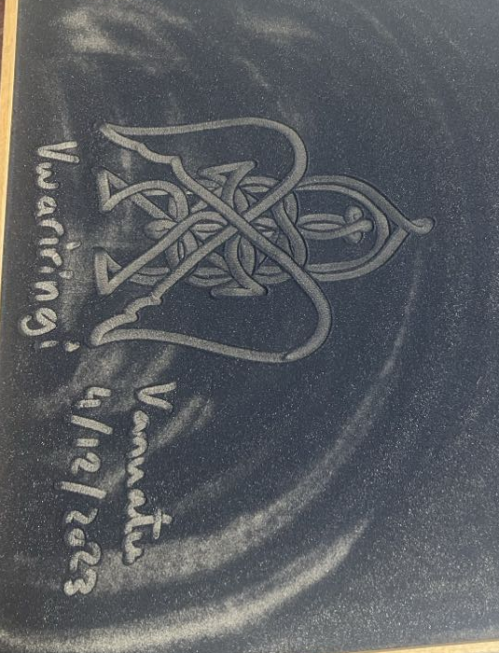
Embarking on a two-week elective in Vanuatu, my hopes were quite low as the journey began due to various unexpected challenges and concerns. A flat tire on the Uber ride to the airport set the tone for a very rocky start. Communication difficulties with the hospital regarding elective fees and ambiguity surrounding the first day of placements fuelled some stress and anxiety. Furthermore, the looming risk of malaria despite being on prophylaxis medication and other communicable diseases such as dengue and having grown up in the cold town of Ballarat, the thought of tropical heat, deadly UVs and possible monsoon-like weather were also on my mind. The only reassuring thing was that I had a fellow colleague going through this with me. However, as the weeks unfolded, these hurdles transformed into something closer to stepping stones for personal and professional growth, which I am extremely grateful to have had the opportunity to experience.
Figure 1 Bwatu Uri Uri (Sand drawing) welcome to Vanuatu 4/12/2023

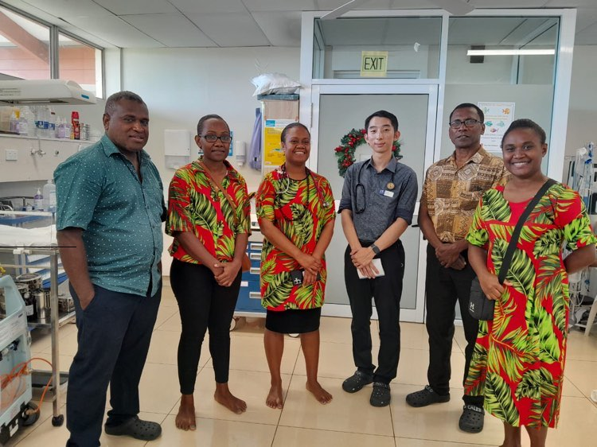
First day at Vila Central Hospital
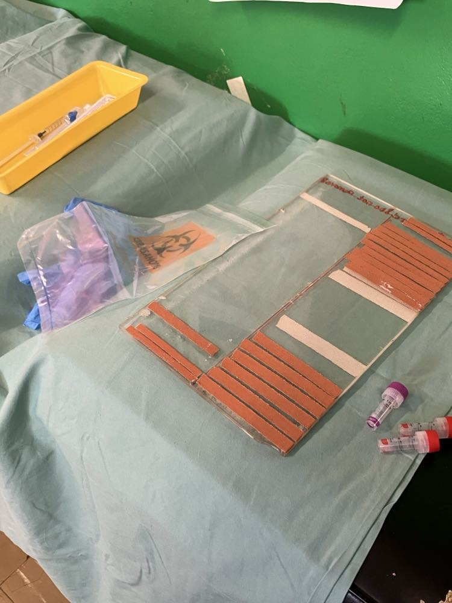
Already drenched in sweat from the walk to the hospital in the blazing tropical sun we attended the first day where we were given a tour around the hospital, fortunately short enough to escape the heat and follow a doctor in the well air-conditioned General Medicine ward. I was able to ease myself into the Vila Central Hospital environment with the ward rounds, clerking and clinics as I had a fellow medical student with me for the first day. This allowed us to discuss and debrief as we were being exposed to a variety of interesting things, and ease into the new hospital environment. The low-resource setting meaning that there were significant differences to views on certain examinations, such as a DRE for abdominal pain symptoms, which in Australia has less of a significance due to further investigations that are routinely ordered. These differences brought excitement and wonder for what new experiences the paediatrics ward, that I had been allocated to would bring.
Figure 2 Paediatrics team in NICU. From left to right; Dr Sam, Dr Jerolin, Dr Annette, Myself, Dr Caleb, Dr Leana

The Paediatrics Ward
Going to the Paediatrics ward, I was given the opportunity to choose to also go to the neonatal nursery/ICU ward. This period allowed me to shadow paediatricians in various settings, participate in clinics, and contribute to patient care by assisting interns with notes. The first week was spent mostly in the paediatrics ward. The ward contained approximately 30 beds shared between paediatric medical patients and paediatric surgical patients. Unlike, Australia, only 4 of these 30 beds were in isolated rooms and the remaining were all in the same corridor-like room, with a lack of curtains to even consider privacy. Likely spanning from the strong views on connection and family, many children had families bringing their own rugs to sit and huddle in the wards to quietly to stay together. Some more key differences to Australia, was that surprisingly all neonates with fever were also sent to this ward. And furthermore, there was a heightened prevalence of infectious diseases most commonly scabies exacerbated by recent cyclones. Witnessing doctors examining patients with scabies, let alone possible dengue and malaria without PPE was a surprise. Many patients encountered on the wards also were suffering with malnutrition. Severe acute malnutrition was very common, with the doctors and hospital highly skilled and comfortable with treating these patients. Lastly, the creative improvisation with substitutes for medical items, like using plastic bottles as asthma pump spacers, illustrated both the lack of resources of the healthcare professionals in Vanuatu and simultaneously their resourcefulness. The subsequent week took place in the neonatal nursery/NICU, which consisted of a single room with 10 incubation cots, and depending on demand, additional cots stations in the middle of the room. The main presentations were premature births/ low weight neonates, or jaundiced neonates. A key difference with Australian hospitals was the lack of access to neonatal ventilators or other machinery, which I fortunately did not see the outcome of the difference.
Figure 3 Preparation for IVC, including a tray of plaster tape ready for taping the IVC to the arm
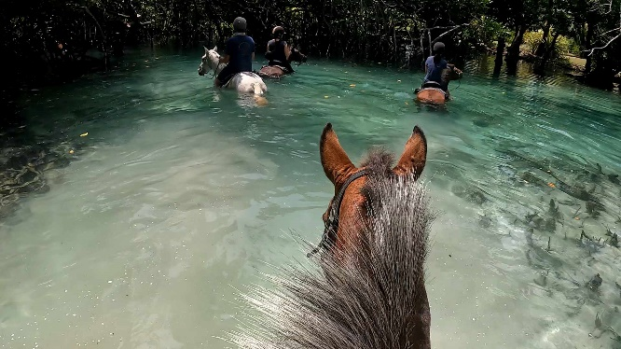
Extra-Curricular Experiences
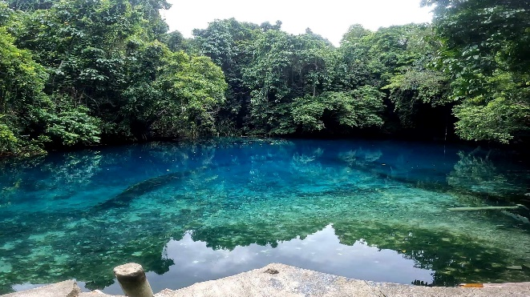
Outside of the elective we had the time and opportunity to experience various activities of which many included guided tours that would somehow always lead to talks regarding traditional herbal medicine, including purple-coleus as iron supplementation in fatigued mothers and the use of green coleus as an antiseptic when cutting the umbilical cord. Beyond the medical realm, the pacific island scenery and waters were very memorable, and unforeseen events added unexpected dimensions to my elective. Waterlogging my phone and an unplanned fall from a horse tested my adaptability and resilience on my final days in Vanuatu. These incidents, though challenging, offered lessons in flexibility and the importance of embracing the unpredictability inherent in such immersive experiences. I believe not many students or doctors have had the pleasure to experience falling off a horse.
Figure 4 Horse riding in Santo Island

Overall Reflection
Through the myriad challenges and enriching experiences, I witnessed the resilience of both the healthcare system and the local community in Vanuatu. The stark contrasts between healthcare practices in Australia and Vanuatu illuminated the profound impact of socio-economic factors on healthcare outcomes. The exposure to diverse medical scenarios hopefully enhanced my paediatric knowledge, clinical skills, and passion for the field. Witnessing the healthcare challenges faced by the people of Vanuatu provided invaluable insights, encouraging a broader perspective on patient care. The prevalence of infectious diseases, resource limitations, and innovative improvisations showcased the need for adaptive and context-specific healthcare approaches. I have considerably enjoyed this experience and look forward to all the experiences that await me in my future journeys.
Figure 5 Matevulu Blue Hole, Santo Island

